Accessing Your Employee Data Screens
Your employee data and reports can be accessed at www.paychexonline.com
To access your data, you must first create an account. Once logged into the website, you begin by choosing the sign up option in the lower left hand corner of the log-in panel.
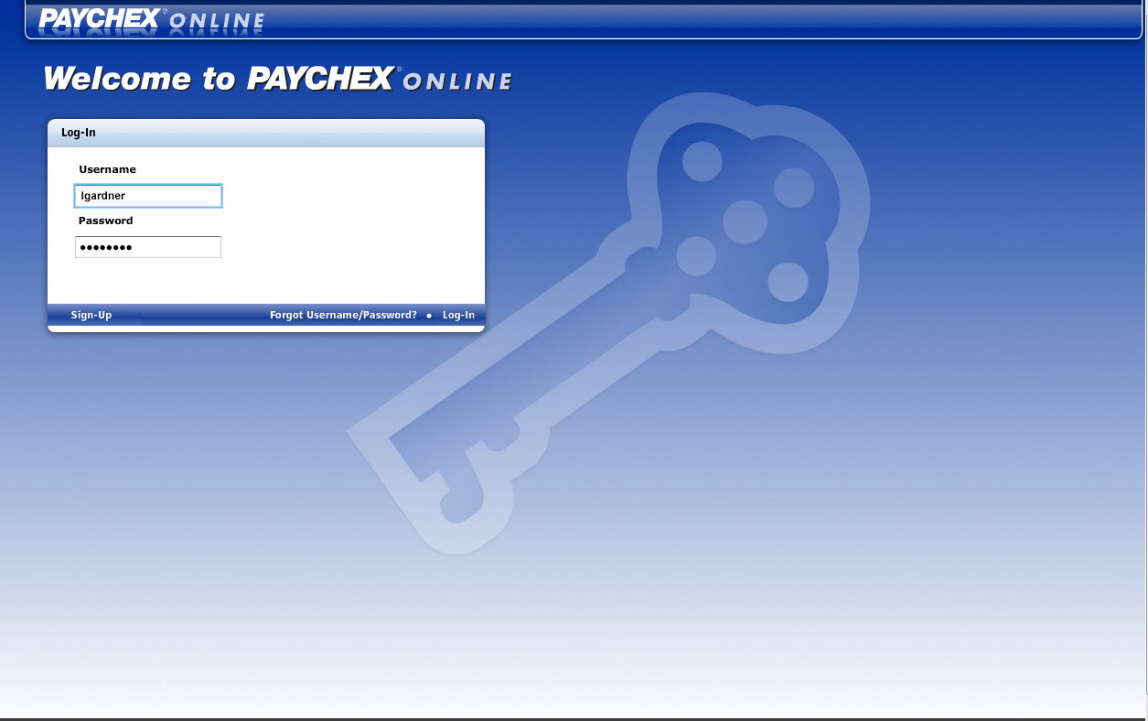
This will bring you to the employee verification page. It is important to complete all of the fields as it will use this information to match you with your company. Once you have completed the information, choose ‘continue’ in the lower right hand corner of the page.
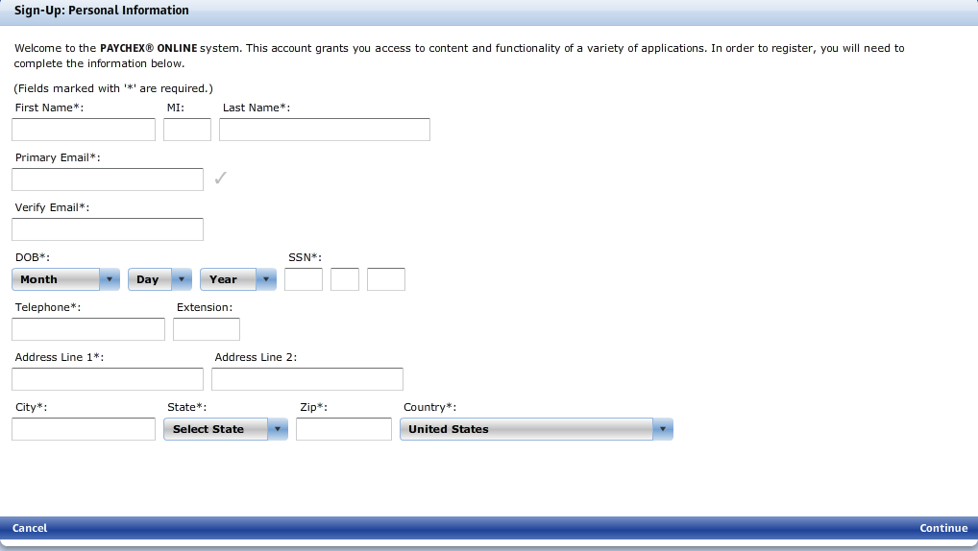
You will then be directed to your security set up. Once completed, click continue in the bottom right hand corner of the page.
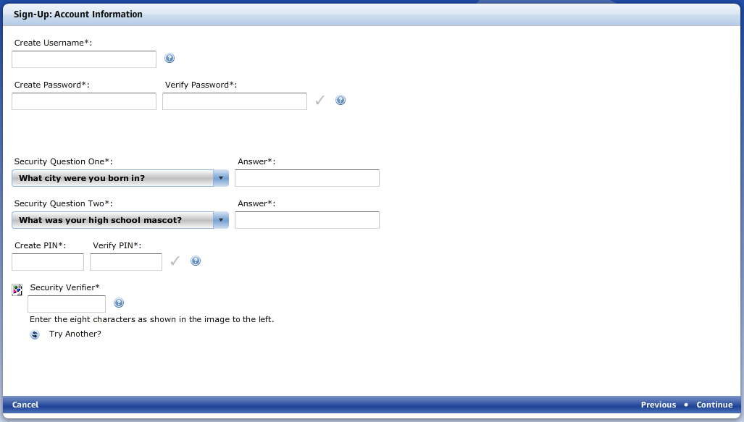
This will complete your account registration and bring you to your employee page. Your check stubs and W2 information can be found in the ‘My Docs’ section. Your personal information can be found through the ‘User Account’ icon.
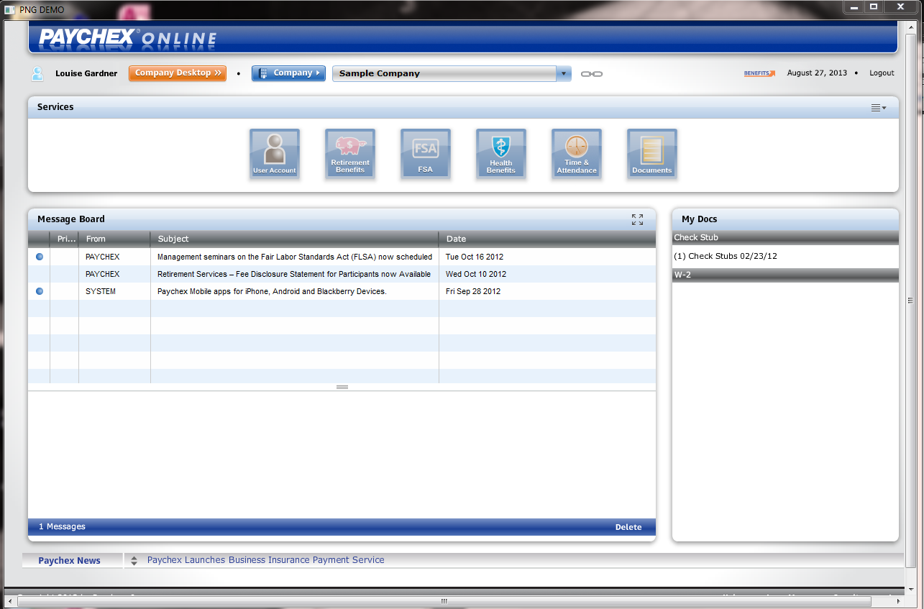
If you experience any issues logging in, please contact the online support team at (888) 246-7500, opt. 3.

